ADASHI Systems LLC

ADASHI Rollcall
17.2
Release Notes

Table of Contents
Contents
1. Introduction 3
2. About This Release 3
3. Compatible Products 3
4. Release / Deployment process 3
4.1 Process 3
5. Features 3
5.1 New Features 3
5.2 Changed Features 4
5.3 Removed Features 5
6. RESOLVED DEFECTS 5
7. Known Bugs and Limitations 6
7.1 General Note 6
7.2 ROLLBACK PROCEDURE 6
8. Documentation 6

Adashi Rollcall 17.1 Release Notes

Introduction
The document communicates the major new features and changes in this release of Adashi Rollcall. It also documents known problems and workarounds if applicable.

About This Release
This is a maintenance release designed to address minor issues and add quality of life adjustments. There is one significant feature change which improves the employee import process and prevents a recurring scenario that locked overtime offers from being edited Additional support documentation and video are provided to ensure all customers are appropriately introduced to new features.

Compatible Products
This product has been tested on the following platforms or with the following products:
- Google Chrome v78 and newer on Windows 10, 8.1
- Mozilla Firefox v72 and newer on Windows 10, 8.1

Release / Deployment process

Process
Adashi support will contact the person designated as your primary contact to schedule a deployment time. A notice will be provided 24 hours before planned site maintenance, and again just before the site comes down. Deployments typically take less than an hour, and the site will work without further customer input upon reactivation.

If desired, prior to or following deployment, Adashi can schedule a walkthrough meeting to introduce trainers or department heads to new features. Access to a link with a copy of these release notes and a set of explanatory videos are provided with the deployment.

Features

New Features
The following new features appear in this release (note that a video review of all additions is provided along with these release notes):
None

Changed Features
The following features have been changed in this release:
- Overtime Offer Resolution – In prior versions of Rollcall, it was too easy to accidentally lock overtime offer imports before an employee was imported, resulting in the user having to delete and resend the offer. The cumbersome two-step process that led to this scenario has been replaced by a much clearer, easier system that no longer presents an opportunity to lock the offer before the import is completed.
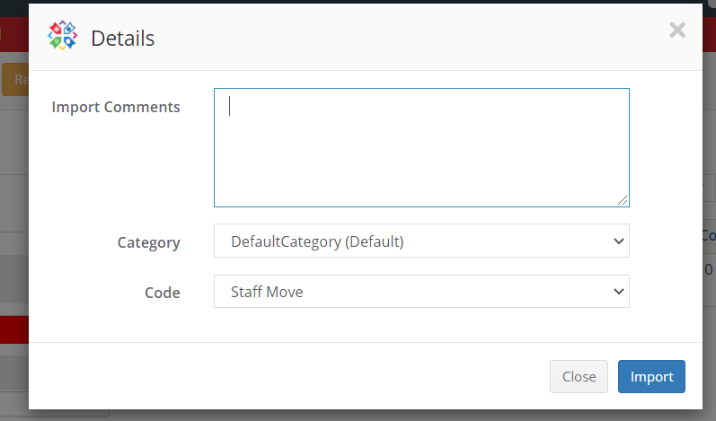
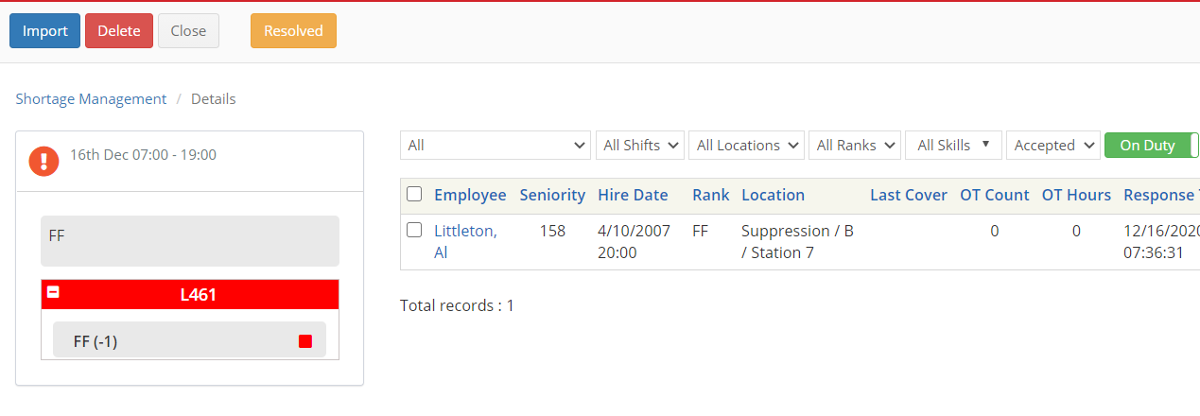
The old import required the user to click the Import button in the upper left, which brought up the popup below where the category and code for the hire was selected. After importing, the user had to remember to click the Resolved button, also in the upper left. If the Resolved button as clicked before the Import however, the offer would be locked, and the user would have to delete and resend.

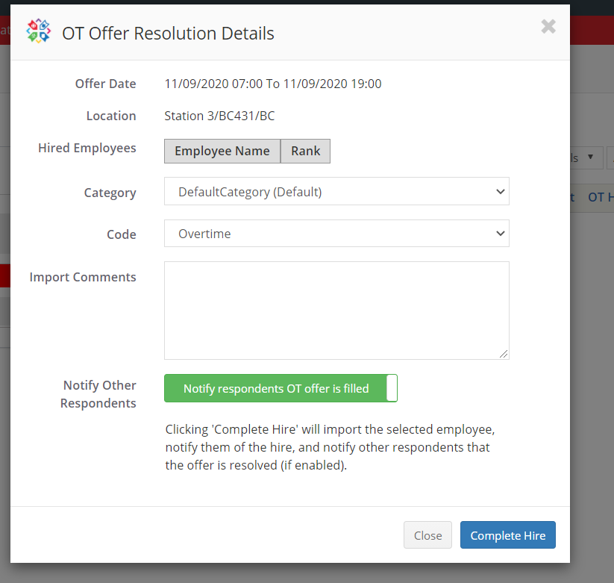
The new import system (shown right) presents more information about the offer being worked on, gives the user the option to turn on or off a notification to all users who were not hired that the offer was resolved, and combines the import and resolve functions into a single action.

- Added the Employee ID to Rollcall web API output
- Added time constraints to the Timesheets page – The addition of editable time constraints gives the user more control over records in Timesheets, preventing shifts from bleeding into one another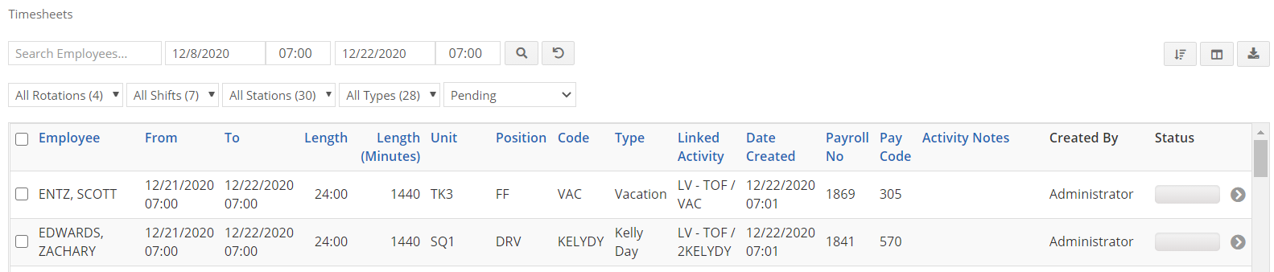
- Made Paycode an optional item in Timesheets
- Modified Paycode column to accept alphanumeric entries

Removed Features
The following features have been removed in this release:
- None

RESOLVED DEFECTS
The following defects have been resolved in this release:
- Resolved a bug that caused incorrect data to appear in the Swapped With column. This column is only for trade codes, but employee names were appearing for other types of shift adjustments. This no longer occurs and the Swapped With column is empty for all other codes. (ARC-496)
- Resolved a bug which caused incorrect data to populate the booking and shift adjustment creation popup on the Situation Board. The Code dropdown was not responding properly to selections in the Category column, leading to error. (ARC-500)
- Resolved a flickering issue with the employee records summary popup on the Situation Board, which customers reported experiencing unintended reloads and sorting selections reverting without user input. (ARC-501)
- Resolved a series of export issues across the program that resulted in missing records when a page was exported to PDF, CSV or Excel. (ARC-504)
- Resolve a bug that returned an error when users attempted to access the booking request page through the Vacation Planner (ARC-504)

Known Bugs and Limitations

General Note
In the Admin section of the program, accessible only with the proper permissions, there is a menu item called Dashboard. Modifying items in here can lead to incorrectly altered department data and other errors. Adashi recommends consulting with IT Support rather than attempting to interact with this section.

ROLLBACK PROCEDURE
In the event of a significant issue with the upgrade, Adashi has a system in place to revert a site to the previous working version. Unfortunately, this means that any new data created in Rollcall between the time of the upgrade and the rollback will be lost. A rollback is a worst-case scenario, and Adashi will do everything possible to prevent such an option from becoming necessary.

Documentation
As part of your department’s purchase of Adashi Rollcall, a set of training videos are made available for you and your employees to learn to use the system. An additional set of videos covering the new features and changes in this update and all previous updates is accessible along with a copy of these release notes here: https://www.adashi.com/rollcall-customers/.
If there is further need for explanation or assistance, please contact us at:
(1) 877.563.9980 during normal business hours and we will be happy to answer your questions, or if required set up a call to address your needs in person.

Revision History
Version | Date | Summary of Changes | Author | Revision Marks  (Yes/No)
1.0 | 12/22/20 | Initial revision | Corey Guen | No

