ADASHI Systems LLC

ADASHI Rollcall
17.3.4
Release Notes

Table of Contents
Contents
1. Introduction 3
2. About This Release 3
3. Compatible Products 3
4. Release / Deployment process 3
4.1 Process 3
5. Features 3
5.1 New Features 3
5.2 Changed Features 4
5.3 Removed Features 5
6. Resolved Defects 5
7. Known Bugs and Limitations 6
7.1 General Note 6
7.2 Rollback Procedure 6
8. Documentation 6

Adashi Rollcall 17.3.3 Release Notes

Introduction
The document communicates the changes and fixes made in this release for Adashi Rollcall version 17.3.4 It also documents known problems and workarounds if applicable.

About This Release
This is a patch release intended to address certain customer issues and fix recently discovered bugs.

Compatible Products
This product has been tested on the following platforms or with the following products:
- Google Chrome v78 and newer on Windows 10, 8.1
- Mozilla Firefox v72 and newer on Windows 10, 8.1

Release / Deployment process

Process
Adashi support will contact the person designated as your primary contact to schedule a deployment time. A notice will be provided 24 hours before planned site maintenance, and again just before the site comes down. Deployments typically take less than an hour, and the site will work without further customer input upon reactivation.

If desired, prior to or following deployment, Adashi can schedule a walkthrough meeting to introduce trainers or department heads to new features. Access to a link with a copy of these release notes and a set of explanatory videos are provided with the deployment.

Features

New Features
- Added a new configuration item designed to preserve select shift adjustment codes when an employee is transferred from one station to another. In short, this system prevents confusion and accidental overwrites by ensuring the preexisting code remains in place. Please contact support with questions or to discuss which codes should be preserved in the event of a staff move.

Changed Features
- We have modified the employee summary popup on the Situation Board and Calendar to present more persistent information, making it easier to make informed decisions when creating bookings and shift adjustments for employees:
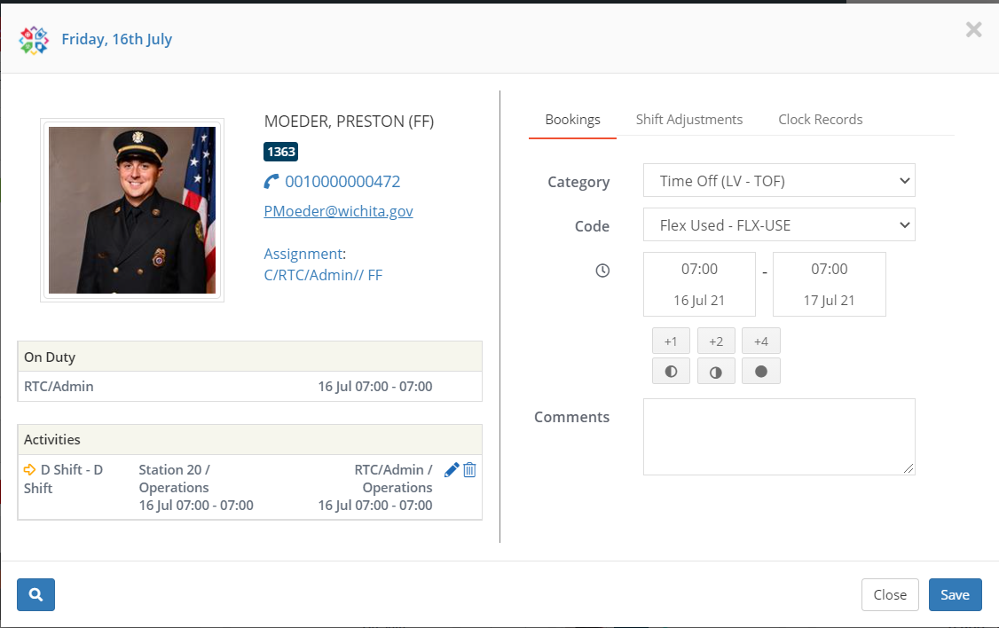
- A confirmation popup was also implemented to prevent accidental saving of additional records.
- Made changes to the password reset system to make it easier to understand and to secure the site link.
- Modified the service number column in Activities > Shift Adjustments and Activities > Requests to match the employee who initiated a trade request. This was done to ensure that administrators responsible for approving and managing trade requests are able to organize based on the employees they’re responsible for.

Removed Features
The following features have been removed in this release:
- None

RESOLVED DEFECTS
The following defects have been resolved in this release:
- ARC-561 – resolved a defect that resulted in incorrect vehicle staffing statuses if an employee transferred to cover a shortage was partially booked off during that shift. Vehicles were given green status even if the employee transferred to cover the shortage did not have the availability to completely cover the shortage (due to sickness, vacation etc), which would result hidden gaps in coverage.
  - To fix this, a warning system was implemented to alert the user that a transferred employee does not have the availability to cover the shortage when the user attempts to create the transfer. The UI changes to the employee summary popup were also implemented in part to address this issue.
- ARC-562 – resolved a defect that hid employees with multiple activity codes from the summary statistics presented in the bottom right corner of the Situation Board. The counts were correct, but clicking on the count to show the list of employee records would hide any employees with multiple activity codes.
- ARC-567 – resolved a defect that prevented some less than full shift adjustments from being created. The time adjustment field would put the next day’s date in incorrectly, and the program would interpret the shift adjustment as running beyond the end of the shift, and prevent creation. The fix prevents the wrong date from hindering shift adjustment creation.
- Resolved a defect that resulted in misalignment of the Roster Quickview when printed.
- Resolved a defect that caused data in certain User Profile fields to disappear when using Single Sign On.
- Resolved a defect that removed the Deny option from Booking Requests, which meant administrators had to delete records rather than deny, which would not send a notification to the affected user. Deny button will now be present for all customers.
- Resolved a defect that crashed the Shift Adjustment History page when a site contained too many shift adjustment codes.
- Resolved several issues with the Rollcall API that resulted in incorrect or incomplete information appearing on the companion mobile applications. These fixes will take effect following the deployment of 17.3.4 code to customer sites and the subsequent release of updated mobile applications, expected to follow shortly.

Known Bugs and Limitations

General Note
In the Admin section of the program, accessible only with the proper permissions, there is a menu item called Dashboard. Modifying items in here can lead to incorrectly altered department data and other errors. Adashi recommends consulting with IT Support rather than attempting to interact with this section.

ROLLBACK PROCEDURE
In the event of a significant issue with the upgrade, Adashi has a system in place to revert a site to the previous working version. Unfortunately, this means that any new data created in Rollcall between the time of the upgrade and the rollback will be lost. A rollback is a worst-case scenario, and Adashi will do everything possible to prevent such an option from becoming necessary.

Documentation
As part of your department’s purchase of Adashi Rollcall, a set of training videos are made available for you and your employees to learn to use the system. An additional set of videos covering the new features and changes in this update and all previous updates is accessible along with a copy of these release notes here: https://www.adashi.com/rollcall-customers/.
If there is further need for explanation or assistance, please contact us at:
(1) 877.563.9980 during normal business hours and we will be happy to answer your questions, or if required set up a call to address your needs in person.

Revision History
Version | Date | Summary of Changes | Author | Revision Marks  (Yes/No)
0.5 | 9/23/21 | Initial revision | Corey Guen | No

